Worship the Lord Your God
Worship has been an important part of the human experience from the beginning of time. Genesis chapter 4 tells of the two sons of Adam and Eve offering sacrifices to Jehovah God who had created them. Even the generations of men who did not see fit to acknowledge God any longer chose instead to worship images of “corruptible man and of birds and four-footed animals and crawling creatures” (Romans 1:23). The wise man wrote of human beings that God had “set eternity in their heart” (Ecclesiastes 3:11) That may say something about our tendency to acknowledge the Divine influence in our existence on this earth, even if some look in the wrong places.
The New Testament was written in the commonly spoken Greek of the first century, and the Holy Spirit chose the word proskuneo to describe worship. Technically the word meant to “kiss toward” as a dog would lick the hand of his master. It was used to denote prostrating oneself in homage or doing reverence to someone.
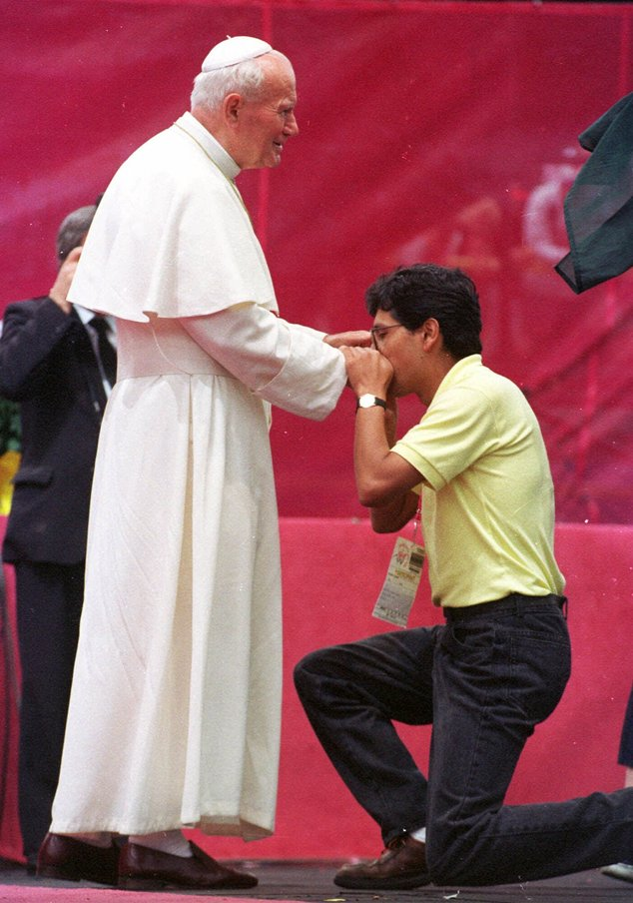
Over the centuries, men have been prone to a misplaced sense of reverence. Consider a few examples:
Other men. Acts 10:25-26 tells us that when Peter entered the house of Cornelius the centurion to teach his household, “Cornelius met him, and fell at his feet and worshiped him. But Peter raised him up, saying, ‘Stand up; I too am just a man.” Some in the religious world will tell you that there are many levels of “veneration” but the Scriptures only refer to two. We all are to honor one another equally (Romans 12:10) and to reserve our reverence and fear for God. Jesus reiterated the instructions of Moses when He said, ‘You shall worship the Lord your God, and serve Him only” (Matthew 4:10). No man of character who understands the Scriptures will allow other men to address him as reverend or kneel before him.
Angels. On two different occasions (Revelation 19:10 and 22:8-9), the apostle John allowed his sense of awe to get the best of him and fell at the feet of angels. In both cases, the angel responded, ‘Do not do that; I am a fellow servant of yours and your brethren who hold the testimony of Jesus; worship God.’” Not even the angels are worthy.
Anything else. Throughout the ages, men have had a weakness for creating their own images to give them something tangible to worship. Literal idolatry is not a great temptation in American society, but there is a spiritual equivalent to which our culture is more susceptible than perhaps any in human history: materialism. Paul warns the Christians in Colossae about abandoning their past vices including greed “which amounts to idolatry” (Colossians 3:5). Images are fresh in my mind of folks pushing and shoving to make sure they get their favorite Black Friday bargains. Affluence can be both a blessing and a curse. We should thank God for our blessings, enjoy the fruits of our labors and consider them as resources for serving God and our fellow man. Anything that I allow to become more important to me than my God is an idol.
Make it your determination to regard all your fellows of high value, refuse to bow before any man as your spiritual master, and to not allow anything to come before your devotion and reverence and fear of God. If you do, you will fulfill the teaching of Scripture and reserve your worship for your Creator who alone is worthy.
John McKee
West Murray church of Christ

